**In-Class Assignment 19**

For the problems below, use the following matrices:

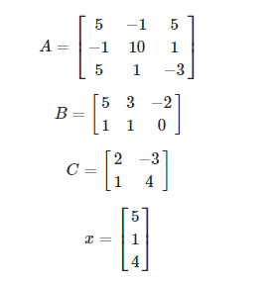

1. Define these matrices in R (using whichever technique you prefer).

1. Compute BA.

1. Compute CB.

1. Find det(C)

1. Compute xTx. Note that this is the square of the norm of x.

1. Solve the following for the unknown y: Ay = x.

1. Find the eigenvalues and eigenvectors of A.

1. Find the eigenvalues and eigenvectors of A2. How do the eigenvalues compare to that of A?

The eigenvalues also got squared with the multiplication of the same matrix, however no change in the eigenvectors.

1. Take a vector z = (1, -3, 4). Re-write z using the eigenvectors of A as the new basis.

